Ropes Course Facilitator Training Workshop
Southern Adventist University
Outdoor Leadership Program
May 4th – 8th

This training offers:
- Low activity and back pocket initiative training
- Skills essential to running a safe challenge course
- Facilitation tools that add meaning to the fun
- A range of hard and soft skills to benefit your program
- A facilitator’s tool kit
- 40 hours of certified training

Contact: Steve Bontekoe
Adventure Programs Coordinator
For the Outdoor Leadership Program
At Southern Adventist University
Via email: Stevebontekoe@gmail.com
Phone: (423)-421-2543
Mail: Po Box 370 Collegedale TN, 37315

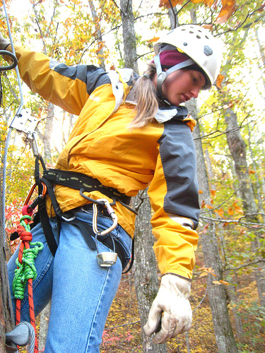
Cost:
Training: $275
Lodging:
$95
Full package:
$370

